**Southern University Bangladesh**

**Department of Computer Science and Engineering**

**Faculty of Science and Engineering**



**Object Oriented Programming Lab**

**Lab Report: 02**

**Course code : CSE 0613-108**

**Submitted by:**

**Name : Sharmistha Chowdhury**

**ID: 666-61-60**

**Submitted to :**

**Mohammed Arif Hasan Chowdhury, Assistant Professor**

**Dept. of Computer Science and Engineering**

**Date : 31/01/2024**

|  |  |  |
| --- | --- | --- |
|  | Index |  |
| Sl | Name of Program | Remarks |
| 1 | Write a Java program to print the sum (addition), multiply, subtract, divide and remainder of two numbers. (Solution 1 & Solution 2) |  |
| 2 | Write a Java program that takes a number as input and prints its multiplication table up to 10. (Solution 1 & Solution 2) |  |
| 3 | Write a Java program to convert a decimal number to an octal number. |  |
| 4 | Write a Java program to print the area and perimeter of a circle. |  |
| 5 | Write a Java program to convert a binary number to a decimal number. |  |
| 6 |  |  |
| 7 |  |  |
| 8 |  |  |
| 9 |  |  |
| 10 |  |  |
| 11 |  |  |
| 12 |  |  |
| 13 |  |  |
| 14 |  |  |
| 15 |  |  |

**Program 01: Write a Java program to print the sum (addition), multiply, subtract, divide and remainder of two numbers.**

**Solution : 01**

**Objective:**

The objective of this Java program is to perform basic arithmetic operations (addition, subtraction, multiplication, division, and modulus) on two user-inputted integers.

**Algorithm:**

* Start the program.
* Import the `java.util.Scanner` class which is used for reading user input.
* Define the `main` method which is the entry point of the program.
* Begin the `main` method.
* Create an instance of `Scanner` to read the input from the standard input (keyboard).
* Prompt the user to input the first number and store this number in the `num1` variable.
* Prompt the user to input the second number and store this number in the `num2` variable.
* Perform the addition operation on `num1` and `num2` and print the result.
* Perform the subtraction operation on `num1` and `num2` and print the result.
* Perform the multiplication operation on `num1` and `num2` and print the result.
* Perform the division operation on `num1` and `num2` and print the result.
* Perform the modulus operation on `num1` and `num2` and print the result.
* End the `main` method.
* End the program.

**Code:**

import java.util.Scanner;

public class Prog1sol1 {

public static void main(String[] args) {

Scanner scanner = new Scanner(System.in);

System.out.print("Input first number: ");

int num1 = scanner.nextInt();

System.out.print("Input second number: ");

int num2 = scanner.nextInt();

System.out.println(num1 + " + " + num2 + " = " + (num1 + num2));

System.out.println(num1 + " - " + num2 + " = " + (num1 - num2));

System.out.println(num1 + " x " + num2 + " = " + (num1 * num2));

System.out.println(num1 + " / " + num2 + " = " + (num1 / num2));

System.out.println(num1 + " mod " + num2 + " = " + (num1 % num2));

}

}

**Input/ Expected Output:**

Input first number: 125

Input second number: 24

125 + 24 = 149

125 - 24 = 101

125 x 24 = 3000

125 / 24 = 5

125 mod 24 = 5

**Screenshot of code edition window:**

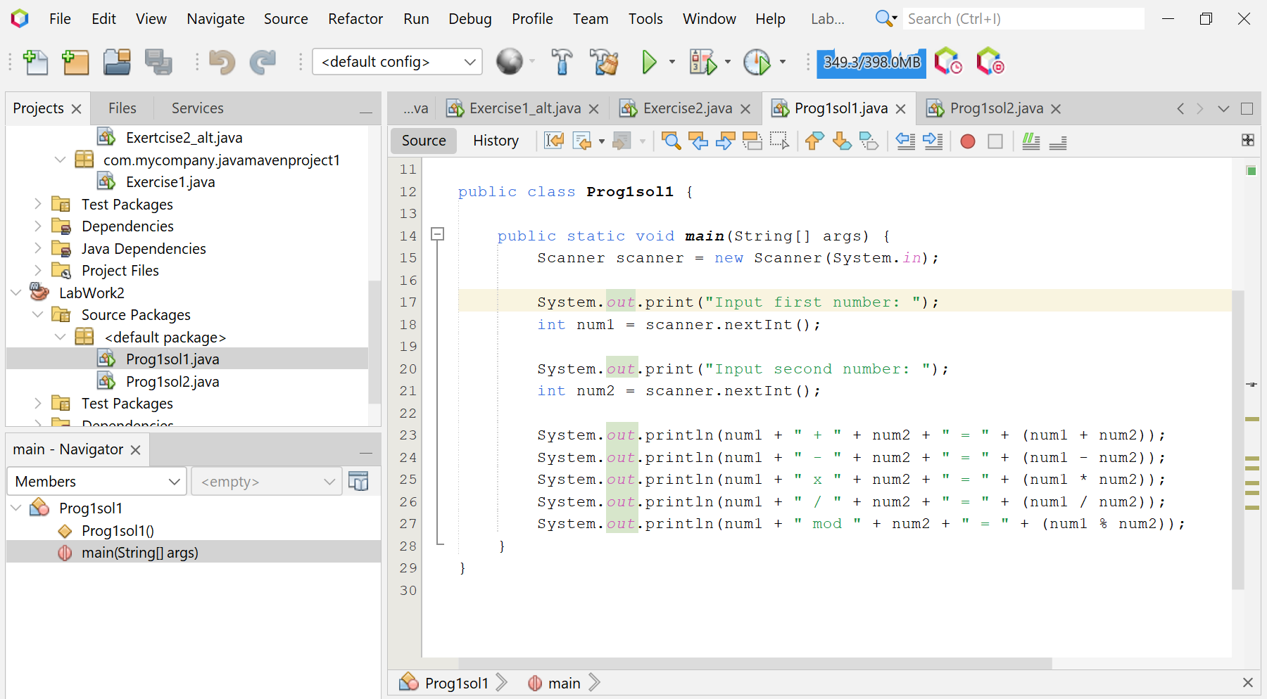

**Screenshot of Output screen/Run screen window**:

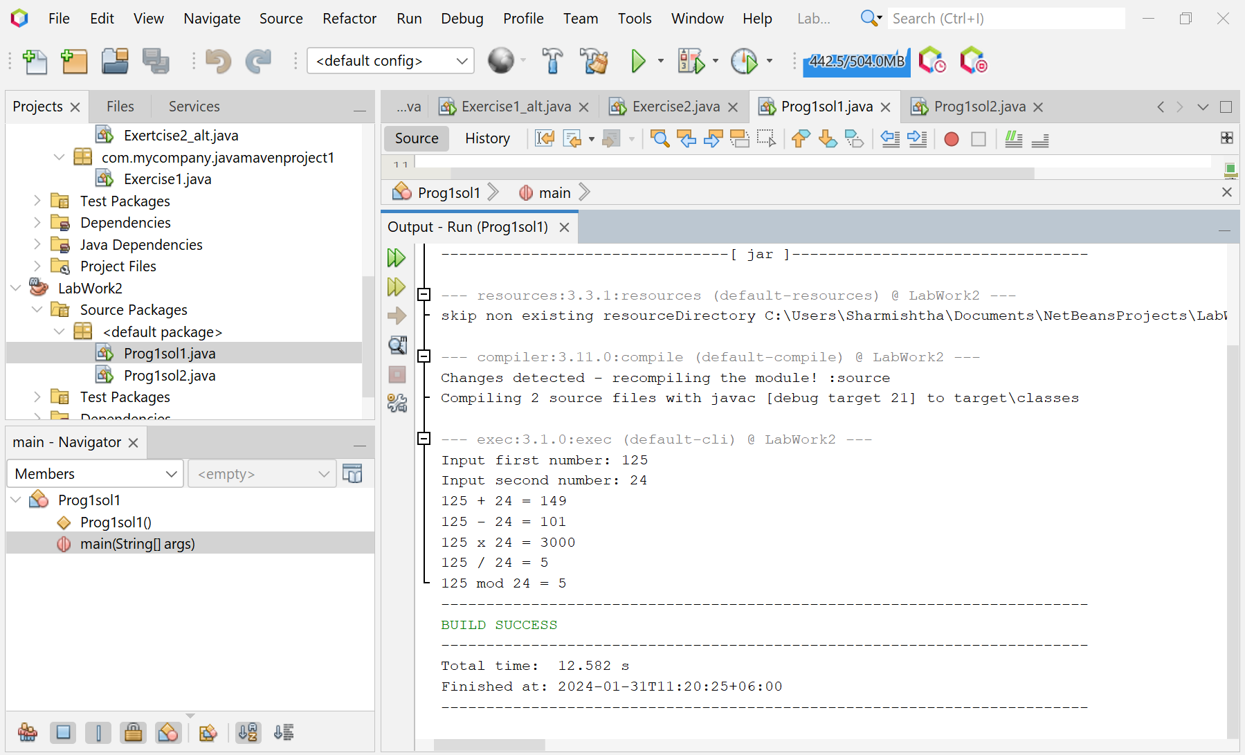

**Explanation :**

* The program begins by importing the `java.util.Scanner` class, which is used to read user input. In the `main` method, an instance of `Scanner` is created to read the input from the standard input (keyboard).
* The program then prompts the user to input the first and second numbers. These numbers are stored in the `num1` and `num2` variables, respectively.
* Next, the program performs the following arithmetic operations on `num1` and `num2`:
  + Addition (`num1 + num2`)
  + Subtraction (`num1 - num2`)
  + Multiplication (`num1 * num2`)
  + Division (`num1 / num2`)
  + Modulus (`num1 % num2`)

The results of these operations are then printed to the standard output.

**Discussion:**

This program effectively demonstrates the use of the `Scanner` class for user input and basic arithmetic operations in Java. However, it does not handle exceptions, such as when a user inputs a non-integer or attempts to divide by zero. To make the program more robust, exception handling could be added. Additionally, the program currently performs operations with integers, but it could be extended to handle floating-point numbers for more complex calculations. Overall, this program serves as a good starting point for anyone learning to interact with users and perform basic operations in Java.

**Solution : 02**

**Code:**

import java.util.Scanner;

public class Prog1sol2 {

public static void main(String[] args) {

Scanner scanner = new Scanner(System.in);

System.out.println("Input the first number: ");

int n1 = scanner.nextInt();

System.out.println("Input the second number: ");

int n2 = scanner.nextInt();

int sum = n1 + n2;

System.out.printf("Sum = %d\n", sum);

int minus = n1 - n2;

System.out.printf("Minus = %d\n", minus);

int multiply = n1 * n2;

System.out.printf("Multiply = %d\n", multiply);

int subtract = n1 - n2;

System.out.printf("Subtract = %d\n", subtract);

int divide = n1 / n2;

System.out.printf("Divide = %d\n", divide);

int rnums = n1 % n2;

System.out.printf("Remainder Of 2 Numbers = %d\n", rnums);

}

}

**Input/ Expected Output:**

Input the first number: 6

Input the second number: 5

Sum = 11

Minus = 1

Multiply = 30

Subtract = 1

Divide = 1

Remainder Of 2 Numbers = 1

**Screenshot of code edition window:**

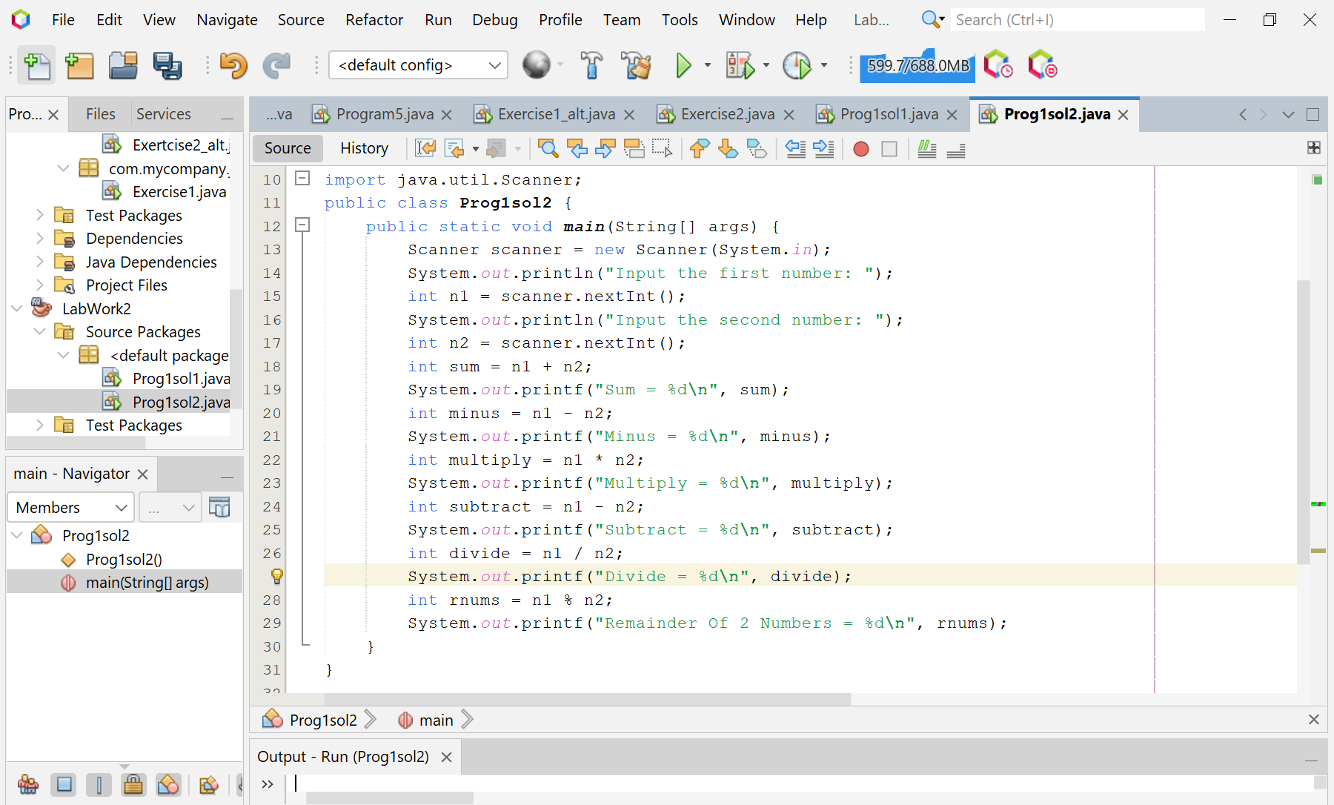

**Screenshot of Output screen/Run screen window**:

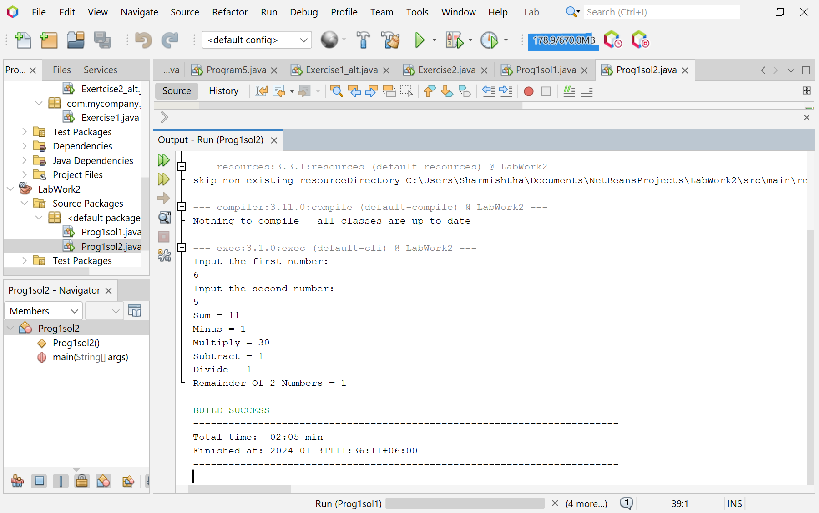

**Problem 02: Write a Java program that takes a number as input and prints its multiplication table up to 10.**

**Solution : 01**

**Objective:**

The main goal of this program is to generate a multiplication table for a given number. This can be useful for educational purposes or for quick reference.

**Algorithm:**

* Start the program.
* Create a new Scanner object to read user input.
* Display a message on the console asking the user to input a number.
* Use the nextInt() method of the Scanner object to read the user’s input number and store it in a variable named num.
* Begin a for loop that iterates from one to ten.
* During each iteration, compute the product of num and the current iteration number.
* Output the result of the multiplication to the console.
* Repeat the previous two steps for each iteration of the loop.
* End the program.

**Code:**

import java.util.Scanner;

public class Prog2sol1 {

public static void main(String[] args) {

Scanner scanner = new Scanner(System.in);

System.out.println("Input a number: ");

int num = scanner.nextInt();

for (int i = 1; i <= 10; i++) {

System.out.println(num + " x " + i + " = " + num * i);

}

}

}

**Input/ Expected Output:**

Input a number: 8

8 x 1 = 8

8 x 2 = 16

8 x 3 = 24

8 x 4 = 32

8 x 5 = 40

8 x 6 = 48

8 x 7 = 56

8 x 8 = 64

8 x 9 = 72

8 x 10 = 80

**Screenshot of code edition window:**

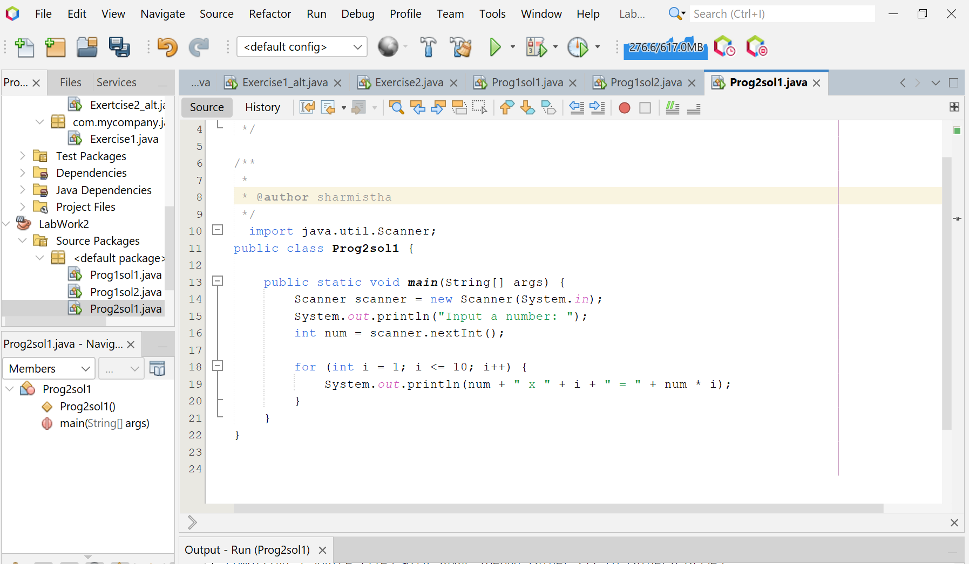

**Screenshot of Output screen/Run screen window**:

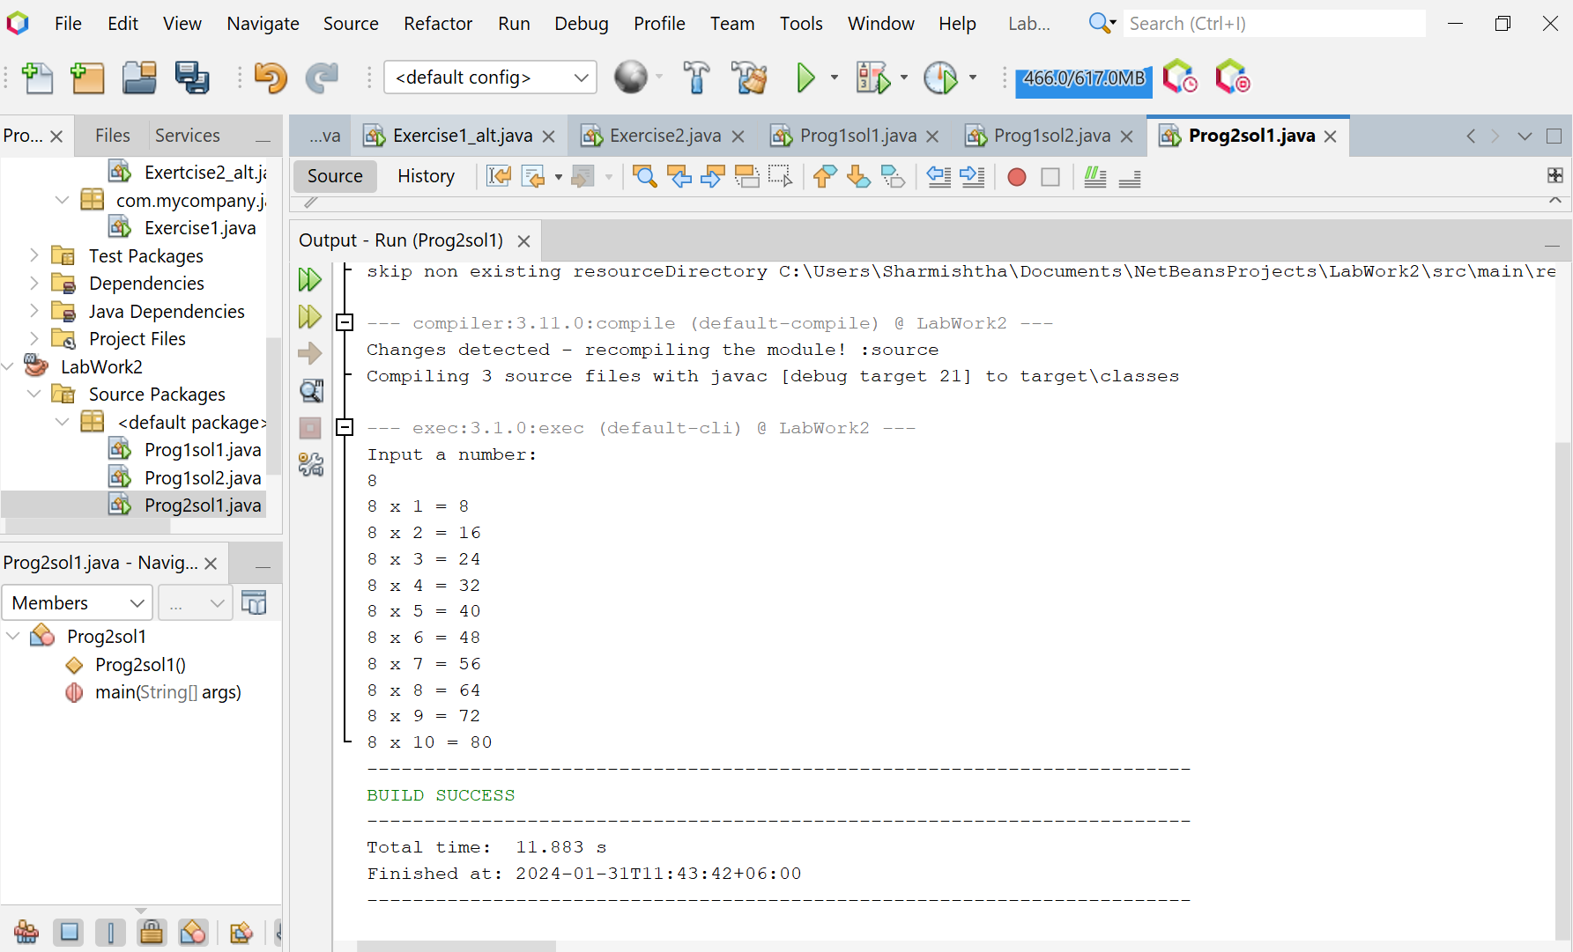

**Explanation :**

* The program begins by initializing a Scanner object to read user input.
* It then prompts the user to enter a number.
* A for loop is used to iterate from 1 to 10.
* In each iteration, the program calculates and prints the product of the input number and the current iteration number.

**Discussion:**

This program is a simple example of how to use loops and user input in Java.It could be extended to allow the user to specify the range of the multiplication table. This program is a good starting point for beginners to understand basic Java programming concepts.

**Solution : 02**

**Code:**

import java.util.Scanner;

public class Prog2sol2 {

public static void main(String[] args) {

Scanner in = new Scanner(System.in);

System.out.println("Input the Number: ");

int n = in.nextInt();

for (int i = 1; i <= 10; i++) {

System.out.println(n + "*" + i + " = " + (n * i));

}

}

}

**Input/ Expected Output:**

Input the Number: 6

6*1 = 6

6*2 = 12

6*3 = 18

6*4 = 24

6*5 = 30

6*6 = 36

6*7 = 42

6*8 = 48

6*9 = 54

6*10 = 60

**Screenshot of code edition window:**

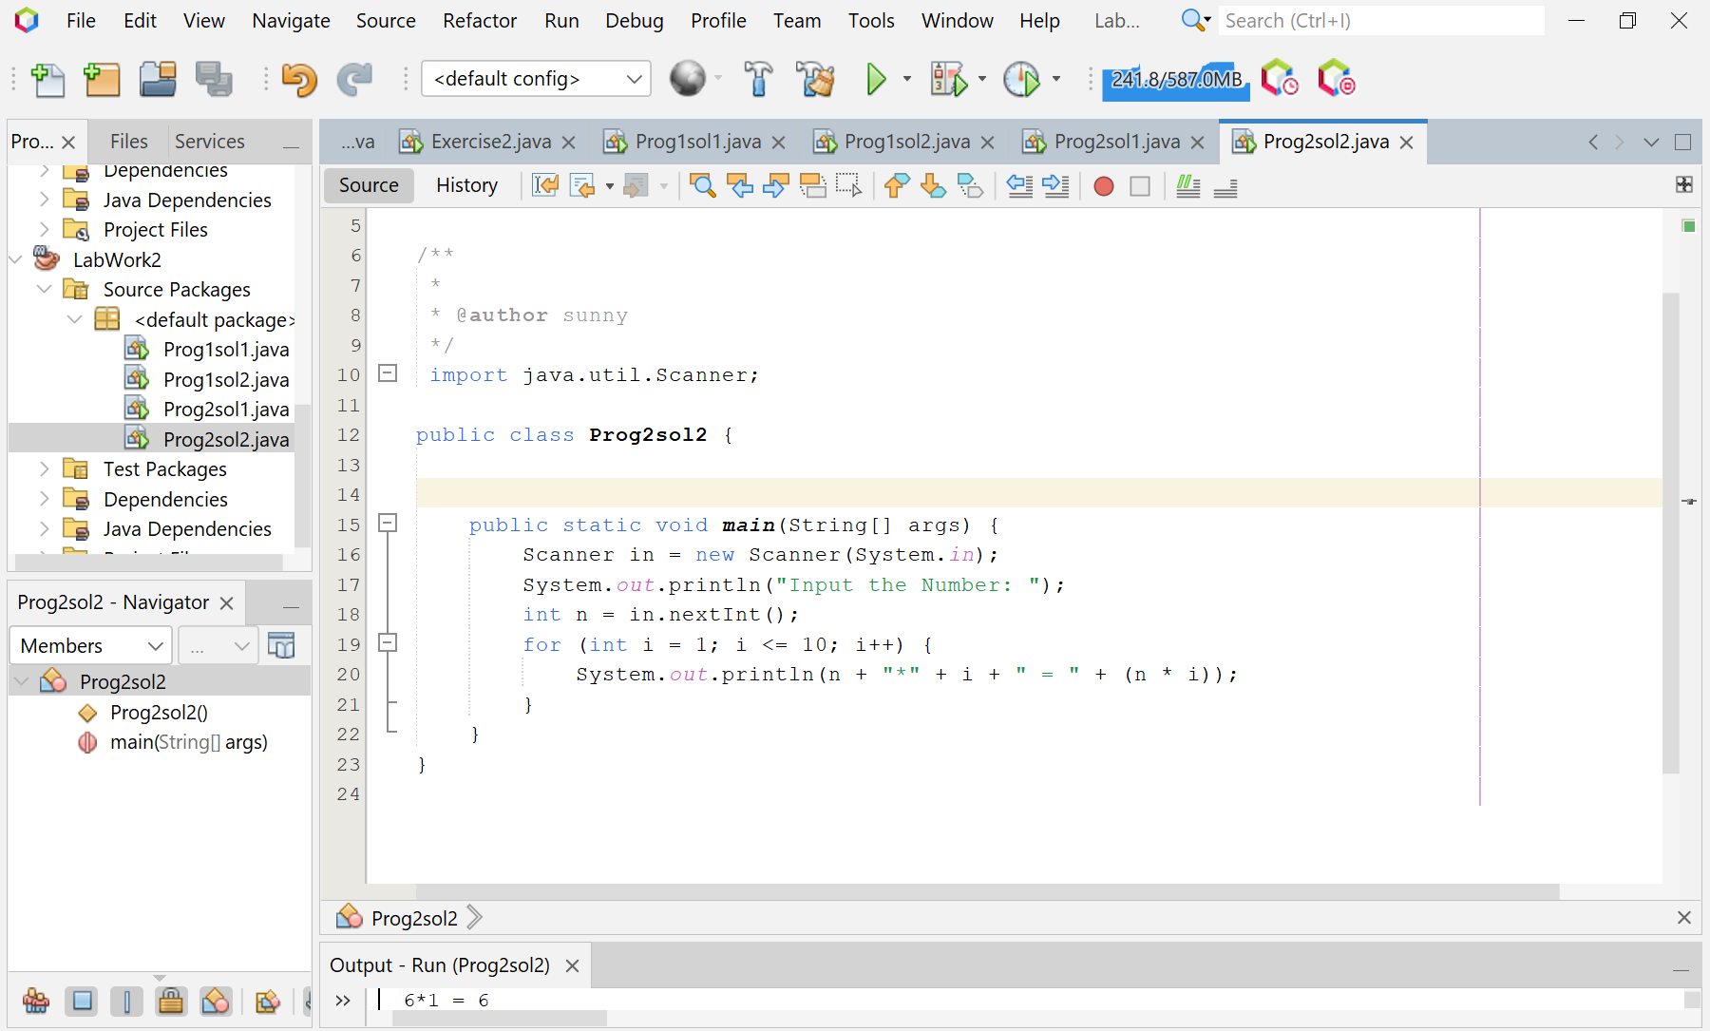

**Screenshot of Output screen/Run screen window**:

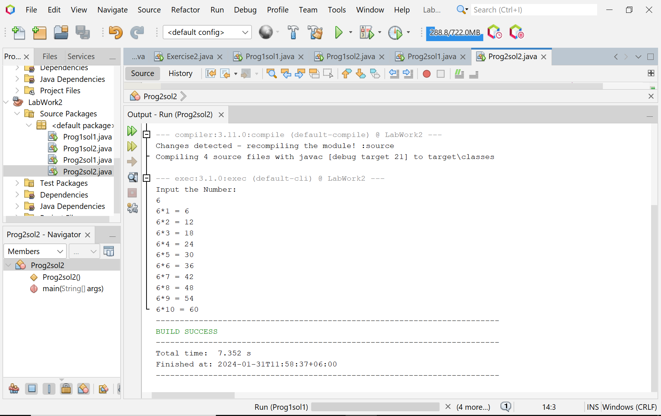

**Problem 03: Write a Java program to convert a decimal number to an octal number.**

**Objective:**

The program’s main objective is to convert a decimal number to an octal number.

**Algorithm:**

* + - * Start the program.
      * Import the Scanner class from the java.util package.
      * Declare the main method of the class.
      * Inside the main method, declare variables dec_num, rem, quot, i, j, and an array oct_num[].
      * Create a new Scanner object to read user input.
      * Display a message on the console asking the user to input a decimal number.
      * Use the nextInt() method of the Scanner object to read the user’s input number and store it in dec_num.
      * Initialize quot with the value of dec_num.
      * Begin a while loop that continues as long as quot is not zero.
      * During each iteration, compute the remainder of quot divided by 8 and store it in the oct_num array at index i. Then, increment i and update quot by dividing it by 8.
      * After the loop, display a message "Octal number is: ".
      * Begin a for loop that iterates from i-1 to 1.
      * During each iteration, print the octal digit stored in oct_num at index j.
      * Print a newline character after the loop.
      * End the main method and the program.

**Code:**

import java.util.Scanner;

public class Prog3 {

public static void main(String args[]) {

int dec_num, rem, quot, i = 1, j;

int oct_num[] = new int[100];

Scanner scan = new Scanner(System.in);

System.out.print("Input a Decimal Number: ");

dec_num = scan.nextInt();

quot = dec_num;

while (quot != 0) {

oct_num[i++] = quot % 8;

quot = quot / 8;

}

System.out.print("Octal number is: ");

for (j = i - 1; j > 0; j--) {

System.out.print(oct_num[j]);

}

System.out.print("\n");

}

}

**Input/ Expected Output:**

Input a Decimal Number: 15

Octal number is: 17

**Screenshot of code edition window:**

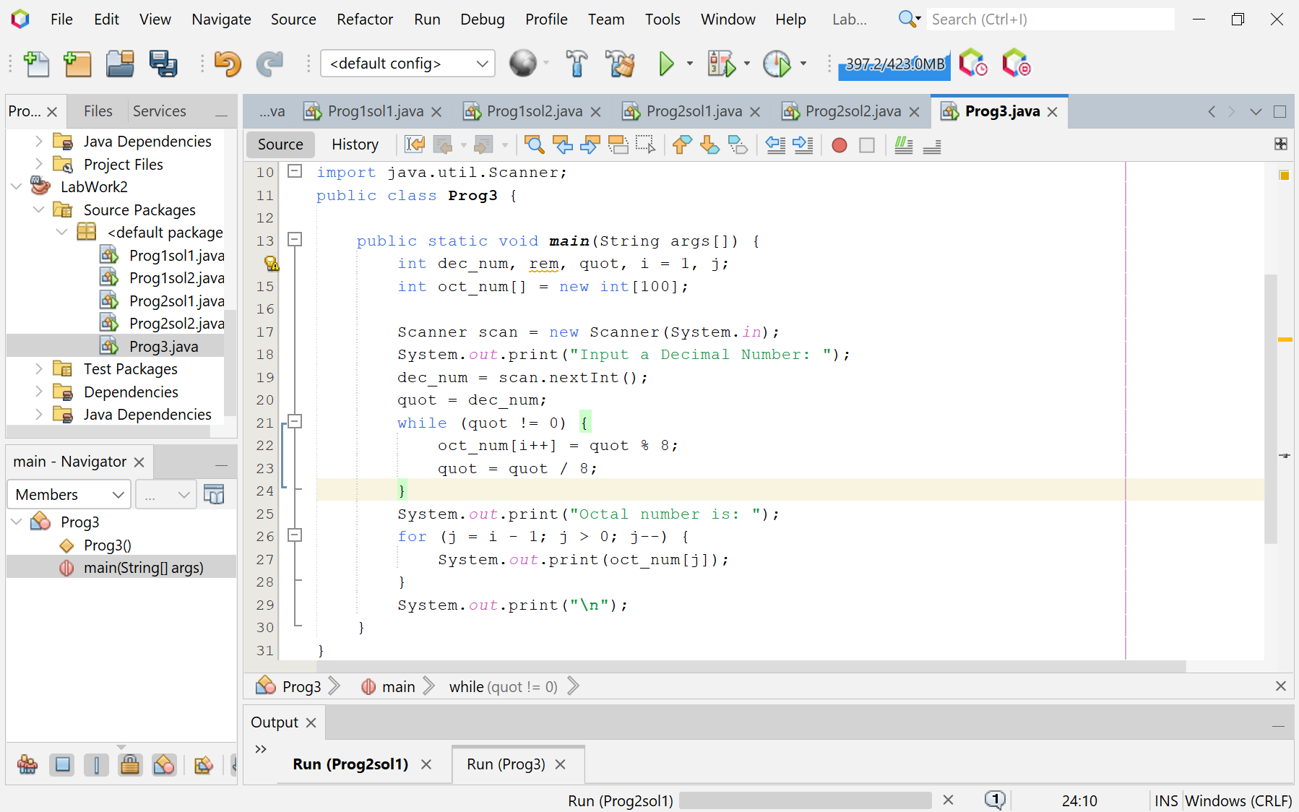

**Screenshot of Output screen/Run screen window**:

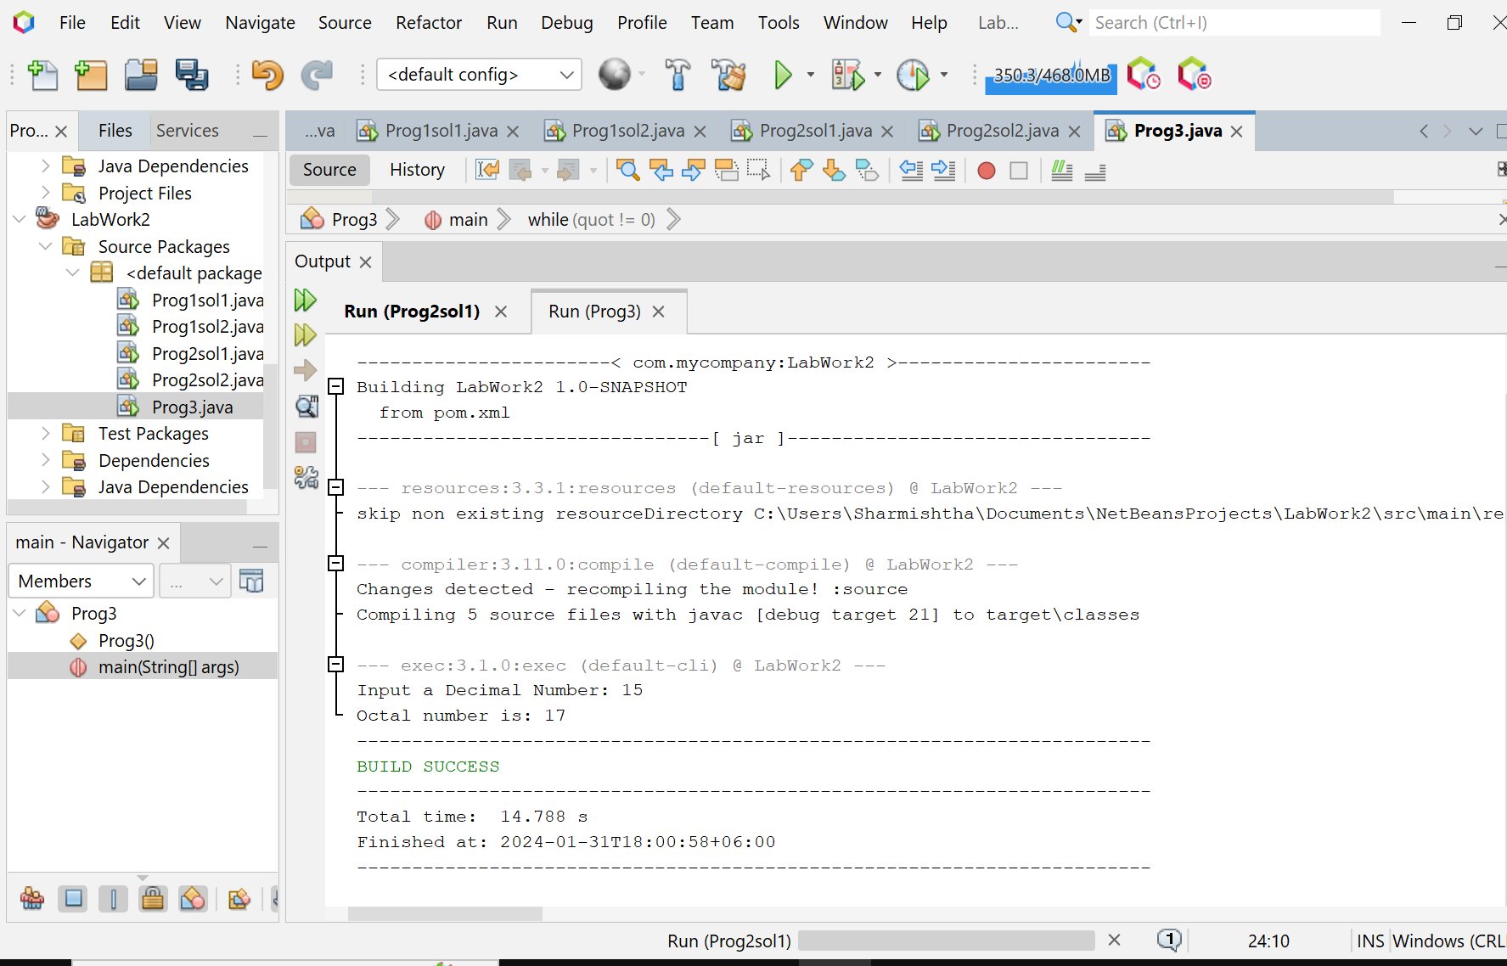

**Explanation :**

* The program starts by importing the java.util.Scanner package which is used to get user input.
* It then declares a class named Prog3.
* Inside the main method, it declares several variables including dec_num (to store the decimal number), rem (to store the remainder), quot (to store the quotient), i and j (as counters), and oct_num (an array to store the octal digits).
* It creates a Scanner object named scan to read the input from the user.
* It prompts the user to input a decimal number and stores this number in dec_num.
* It initializes quot with dec_num.
* It enters a while loop where it calculates the remainder of quot divided by 8 and stores it in the oct_num array. It then updates quot by dividing it by 8. This loop continues until quot is not zero.
* Finally, it prints out the octal number by reading the oct_num array in reverse order..

**Discussion:**

This program is a simple example of how to use loops, arrays, and user input in Java.

It demonstrates the process of converting a decimal number to an octal number, which is a common operation in computer science and digital electronics.The program could be extended to handle negative numbers and floating-point numbers.This program is a good starting point for beginners to understand basic Java programming concepts such as loops, arrays, and user input.

**Problem 04: Write a Java program to print the area and perimeter of a circle.**

**Objective:**

The program’s main objective is to calculate and print the area and perimeter of a circle given the radius.

**Algorithm:**

* Start the program.
* Import the Scanner class from the java.util package.
* Declare the main method of the class.
* Inside the main method, create a new Scanner object to read user input.
* Display a message on the console asking the user to input the radius of the circle.
* Use the nextDouble() method of the Scanner object to read the user’s input radius and store it in a variable named radius.
* Compute the perimeter of the circle using the formula 2 * π * radius.
* Compute the area of the circle using the formula π * radius * radius.
* Output the result of the perimeter to the console.
* Output the result of the area to the console.
* End the main method and the program.

**Code:**

import java.util.Scanner;

public class Prog4 {

public static void main(String[] args) {

Scanner scanner = new Scanner(System.in);

System.out.println("Enter the radius of the circle:");

double radius = scanner.nextDouble();

double perimeter = 2 * Math.PI * radius;

double area = Math.PI * radius * radius;

System.out.println("Perimeter is = " + perimeter);

System.out.println("Area is = " + area);

}

}

**Input/ Expected Output:**

Enter the radius of the circle: 7.5

Perimeter is = 47.12388980384689

Area is = 176.71458676442586

**Screenshot of code edition window:**

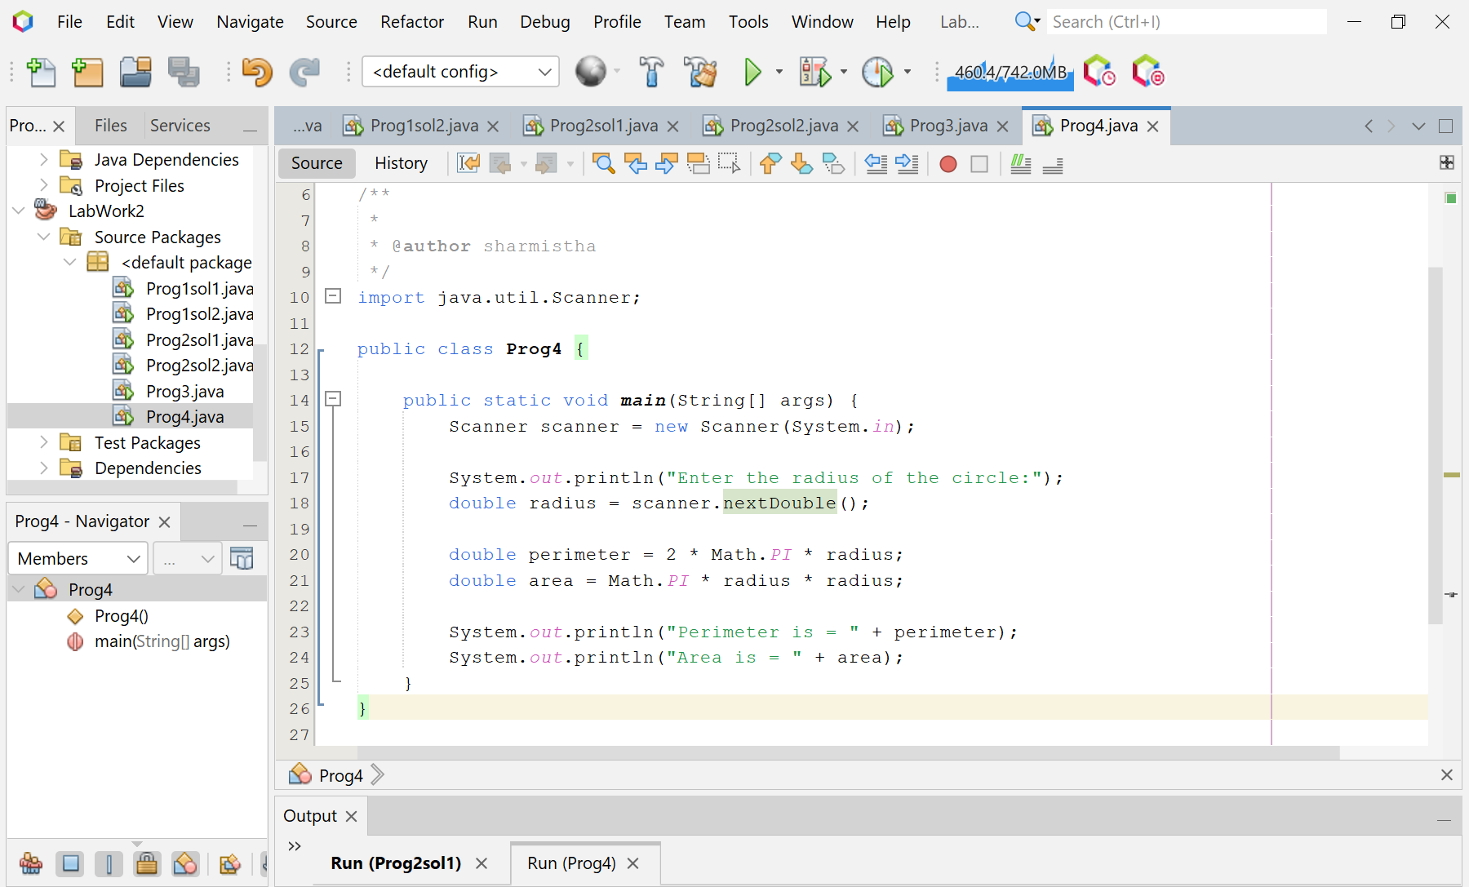

**Screenshot of Output screen/Run screen window**:

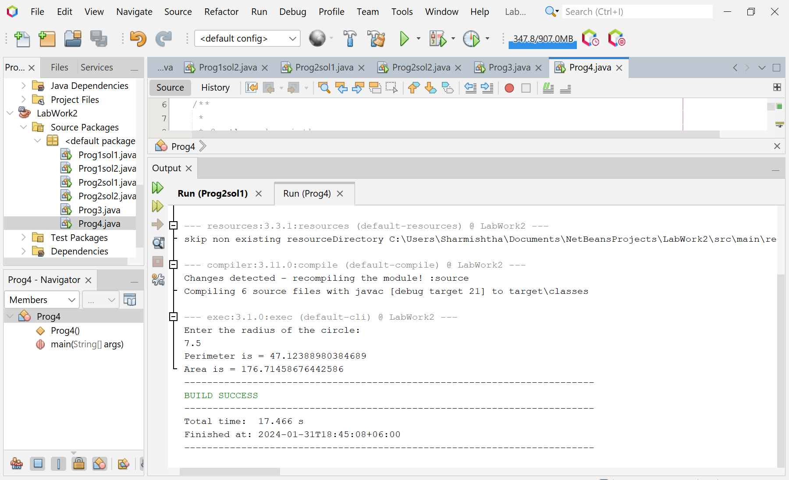

**Explanation :**

* The program begins by importing the java.util.Scanner package which is used to get user input.
* It then declares a class and the main method.
* Inside the main method, it initializes a Scanner object to read user input.
* It prompts the user to enter the radius of the circle.
* It calculates the perimeter of the circle using the formula 2 * π * radius.
* It calculates the area of the circle using the formula π * radius * radius.
* Finally, it prints the calculated perimeter and area.

**Discussion:**

This program is a simple example of how to use user input, mathematical calculations, and output in Java. It demonstrates the use of the Math.PI constant and the Math.pow method provided by Java. The program could be extended to handle negative numbers and zero as input, and provide appropriate messages in such cases. This program is a good starting point for beginners to understand basic Java programming concepts such as user input, mathematical operations, and output.

**Problem 05: Write a Java program to convert a binary number to a decimal number.**

**Objective:**

The program’s main objective is to convert a binary number to a decimal number.

**Algorithm:**

* Start the program.
* Import the Scanner class from the java.util package.
* Declare the main method of the class Prog5.
* Inside the main method, create a new Scanner object to read user input.
* Display a message on the console asking the user to input a binary number.
* Use the nextLine() method of the Scanner object to read the user’s input binary number and store it in a variable named binaryString.
* Trim any leading or trailing spaces from binaryString.
* Convert binaryString to a decimal number using the Integer.parseInt method with radix 2, and store the result in a variable named decimalNumber.
* Output the decimalNumber to the console.
* End the main method and the program.

**Code:**

import java.util.Scanner;

public class Prog5 {

public static void main(String[] args) {

Scanner scanner = new Scanner(System.in);

System.out.println("Input a binary number:");

String binaryString = scanner.nextLine().trim(); // trim leading and trailing spaces

int decimalNumber = Integer.parseInt(binaryString, 2);

System.out.println("Decimal Number: " + decimalNumber);

}

}

**Input/ Expected Output:**

Input a binary number: 100

Decimal Number: 4

**Screenshot of code edition window:**

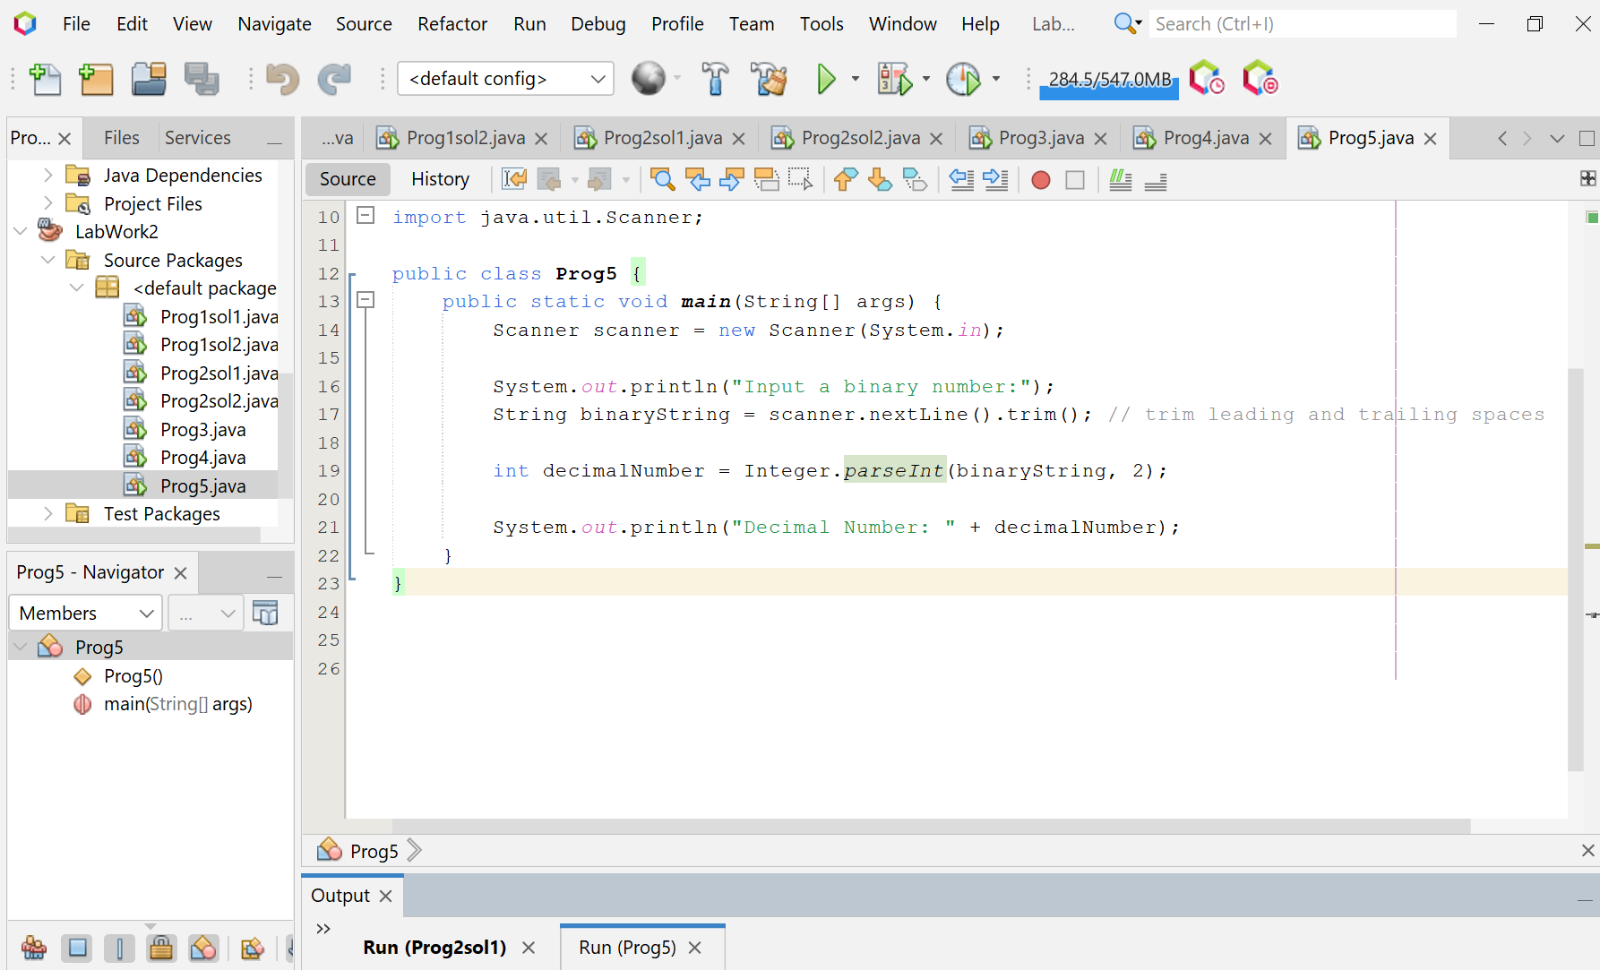

**Screenshot of Output screen/Run screen window**:

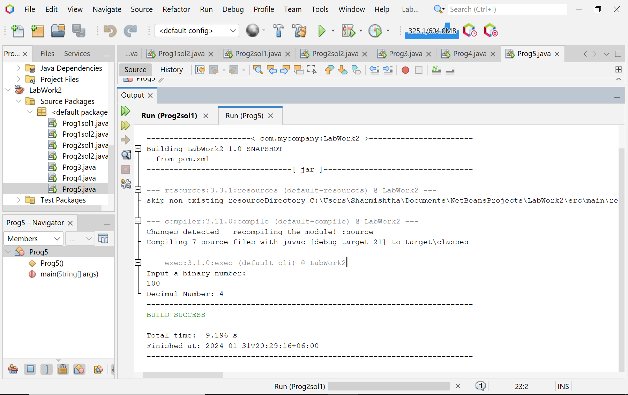

**Explanation :**

* The program begins by initializing a Scanner object to read user input.
* It then prompts the user to enter a binary number.
* The entered binary number is read and stored in a variable.
* The program then uses the Integer.parseInt method to convert the binary number to a decimal number

**Discussion:**

This program is a simple example of how to use user input and built-in methods in Java to perform binary to decimal conversion. It could be extended to handle binary numbers of any length and provide appropriate messages for invalid inputs. This program is a good starting point for beginners to understand basic Java programming concepts such as user input, binary to decimal conversion, and output.